Email subject line: [Account Name]-Hanover Claims Manager Portal Access (hanoversecure) * Do NOT reply *
____________________________________________________________________________________________________

Please do NOT reply to this email. Any questions, start a new email to HCMAccess@hanover.com.

Dear [User Name],

We are pleased to provide you with your [Account Name] Hanover Claims Manager (HCM) log on credentials and portal link. Please read all instructions and troubleshooting tips first.

Once you have logged into HCM, you will have access to our self-guided online training tutorial to assist you in navigating the portal. After logging into HCM, click on HCM Help Tutorial on the left side under Tools & Information.

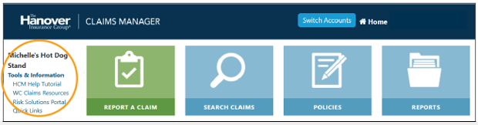

If you wish to Bookmark/Save to Favorites the link, please do so AFTER logging in. Doing so prior will not allow you to log in. At this time, please do not change your password unless your company requires it. If you need to, do not Bookmark/Save the link until you change your password, log out then re-log in successfully with the new password.

Troubleshooting Tips:

- If you wish to save the link to your Favorites/bookmark it, please do so AFTER you have logged in.
- Due to different customer firewalls some browsers work better than others. Users typically experience the most optimal performance of the application when HCM is accessed through Google Chrome. If you have issues using your normal browser and have the option of trying another, please do so. If you continue to have problems, please contact us.
- Try clearing your cache/history.
- Password reset requests and general inquiries can be directed to: Michelle Bond at 508-855-8270 or email HCMAccess@hanover.com. Please do not call the number on the screen or click on the link.

To access HCM copy and paste the link into your internet browser:

http://myaccountnew.allmerica.com/

Upon accessing the portal, you will be asked to log in. Your username and password are:

User ID: [User ID]
Password: [Production Password] (case sensitive)
There will also be a Multi-factor Authentication (MFA) sent to your email on file. Please allow up to five minutes for this email to arrive.

VERY IMPORTANT! For password resets or log in issues, please have your Account Customer # [Cust #] and policy zip code (00001) available when calling.

If other users within [Account Name] require access to HCM, please email HCMAccess@Hanover.com with a request and we will respond appropriately.

Please contact us with any questions.

Sincerely,

The Hanover Special Accounts Claims Team

Toll-Free: 800-628-0250 x855-8270
Direct: 508-855-8270
Email: HCMAccess@hanover.com
Fax: 774-436-4626


Any person who knowingly and with intent to defraud any insurance company or other person files an application for insurance containing any materially false information or conceals, for the purpose of misleading, information concerning any fact material thereto commits a fraudulent insurance act, which is a crime and subjects that person to criminal and civil penalties (In Oregon, the aforementioned actions may constitute a fraudulent insurance act which may be a crime and may subject the person to penalties). (In New York, the civil penalty is not to exceed five thousand dollars ($5,000) and the stated value of the claim for each such violation).

